**TASK -1**

**PORTFOLIO**

**Home.html**

**Description**

Html tag

Head tag

Body tag

Header tag

Footer tag

Section tag

Heading tags

Style tag

Body tag

Span tag

Division tag

Paragraph tag

**Source Code**

<!DOCTYPE html>

<html lang="en">

<head>

    <meta charset="UTF-8">

    <meta http-equiv="X-UA-Compatible" content="IE=edge">

    <meta name="viewport" content="width=device-width, initial-scale=1.0">

    <title>Portfolio Website Design</title>

    <link rel="stylesheet" href="Hom.css">

    <link rel="stylesheet" href="Home.css">

    <script src="https://kit.fontawesome.com/c3171e834c.js" crossorigin="anonymous"></script>

</head>

<body>

    <header>

        <div class="head-section layout">

            <div class="nav-bar flex space-between align-center">

                <div class="logo uppercase f-w-700 letter-spacing2"><span>LAKSHIT</span> SHRIMALI</div>

                <div class="nav-links">

                    <ul class="flex f-w-600">

                        <li><a href="Home.html">Home</a></li>

                        <li><a href="Aboutme.html">About Me</a></li>

                        <li><a href="#"></a></li>

                        <li><a href="Contact.html">Contact Me</a></li>

                    </ul>

                </div>

                <button class="btn hire-me-btn">Hire Me</button>

                <input type="checkbox" name="checkbox" id="click">

                <label for="click" class="menu-btn" id="menu">

                    <i class="fa-solid fa-bars"></i>

                </label>

            </div>

            <div class="content flex align-center">

                <div class="left flex2">

                    <h4 class="uppercase letter-spacing2">I'm <span>LAKSHIT SHRIMALI</span> </h4>

                    <h2 class="my-t-10 uppercase letter-spacing2 f-w-700">College Student </h2>

                    <p class="my-t-10">I am a highly motivated first-year student pursuing a Bachelor's degree in Computer Science. With a passion for technology and a strong desire to contribute to the field. I am eager to embark on a Journey of leaming and growth

                        My curiosity and drive to stay updated with the latest technological advancements have led me  to explore emerging fields like artificial intelligence, machine learning, and cybersecurity. I am excited to delve deeper into these areas and apply my knowledge to create innovative solutions.

                    </p>

                    <button class="btn btn2 my-t-20">Download CV</button>

                </div>

                <div class="right flex3">

                    <img src="WhatsApp Image 2024-01-28 at 22.54.43_cff05aa9.jpg"  alt="image">

                </div>

            </div>

        </div>

    </header>

    <section class="about-me-sec">

        <div class="about-sec layout">

            <h3 class="uppercase pd-t-30 text-center">About Me</h3>

            <hr class="w55 my-t-10">

            <div class="about-content flex justify-center align-center">

                <div class="left flex2">

                    <h2 class="uppercase letter-spacing2">Web Desinger</h2>

                    <p class="my-t-10">I am a professional web designer and youtuber. I have done many projects for my clients. I am a part time freelancer and I do freelancing in part time.</p>

                    <ul>

                        <li><span class="f-w-600">HTML/CSS/JavaScript</span></li>

                    </ul>

                    <button class="btn my-t-20">Hire Me</button>

                </div>

                <div class="right flex3">

                    <hr>

                    <div class="dot-color text-center my-t-10">

                        <h3>color used</h3>

                        <span class="dot dot-w"></span>

                        <span class="dot dot-b"></span>

                        <span class="dot dot-ws"></span>

                        <span class="dot dot-bs"></span>

                        <span class="dot dot-a"></span>

                    </div>

                </div>

            </div>

        </div>

    </section>

    <section class="portfolio-sec">

        <div class="portfolio layout">

            <h3 class="uppercase text-center pd-30">Portfolio</h3>

            <div class="portolio-parent flex justify-center align-center text-center">

                <div class="portfolio-child">

                    <h3>Digital Marketing Website</h3>

                    <p>Lorem ipsum dolor sit amet consectetur adipisicing elit. Quidem vero hic vitae numquam adipisci expedita!</p>

                    <button class="btn btn2">Explore More</button>

                </div>

                <div class="portfolio-child">

                    <h3>Food Delivery Website</h3>

                    <p>Lorem ipsum dolor sit amet consectetur adipisicing elit. Quidem vero hic vitae numquam adipisci expedita!</p>

                    <button class="btn btn2">Explore More</button>

                </div>

                <div class="portfolio-child">

                    <h3>Social Media Website</h3>

                    <p>Lorem ipsum dolor sit amet consectetur adipisicing elit. Quidem vero hic vitae numquam adipisci expedita!</p>

                    <button class="btn btn2">Explore More</button>

                </div>

            </div>

        </div>

    </section>

    <section class="experience-sec">

        <div class="experience layout">

            <h3 class="uppercase pd-30 text-center">Experience</h3>

            <div class="experience-details flex space-between text-center">

                <div class="col">

                    <h3>10+</h3>

                    <p>Complete Website</p>

                </div>

                <div class="col">

                    <h3>50</h3>

                    <p>Landing Page</p>

                </div>

                <div class="col">

                    <h3>15</h3>

                    <p>Client</p>

                </div>

                <div class="col">

                    <h3>4</h3>

                    <p>Projects</p>

                </div>

            </div>

        </div>

    </section>

    <footer>

        <div class="footer-sec layout text-center">

            <p>Copyright &copy; LAKSHIT SHRIMALI| All Right Reserved</p>

        </div>

    </footer>

</body>

    </html>

**Output**

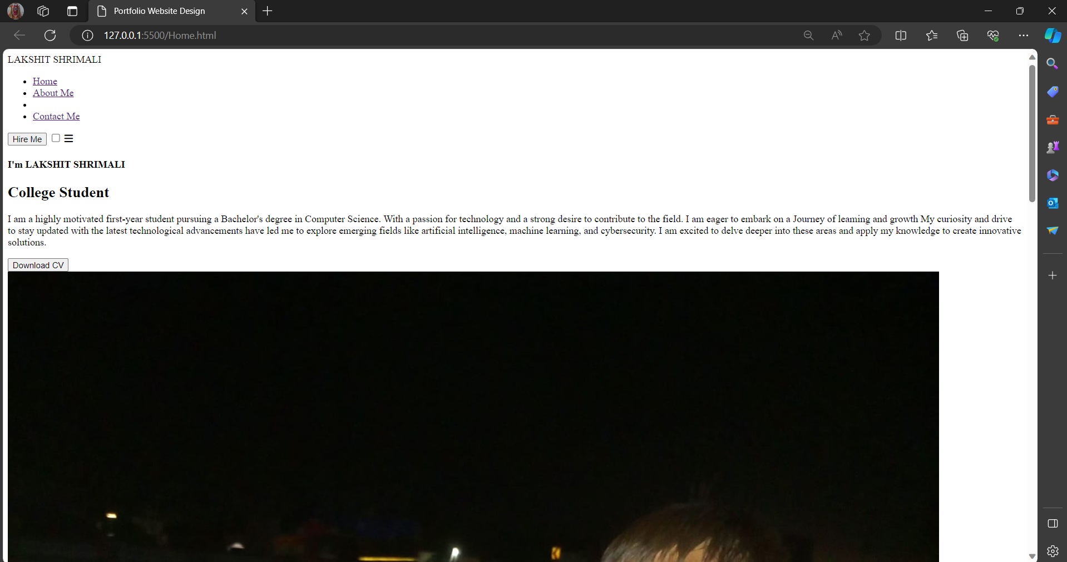

–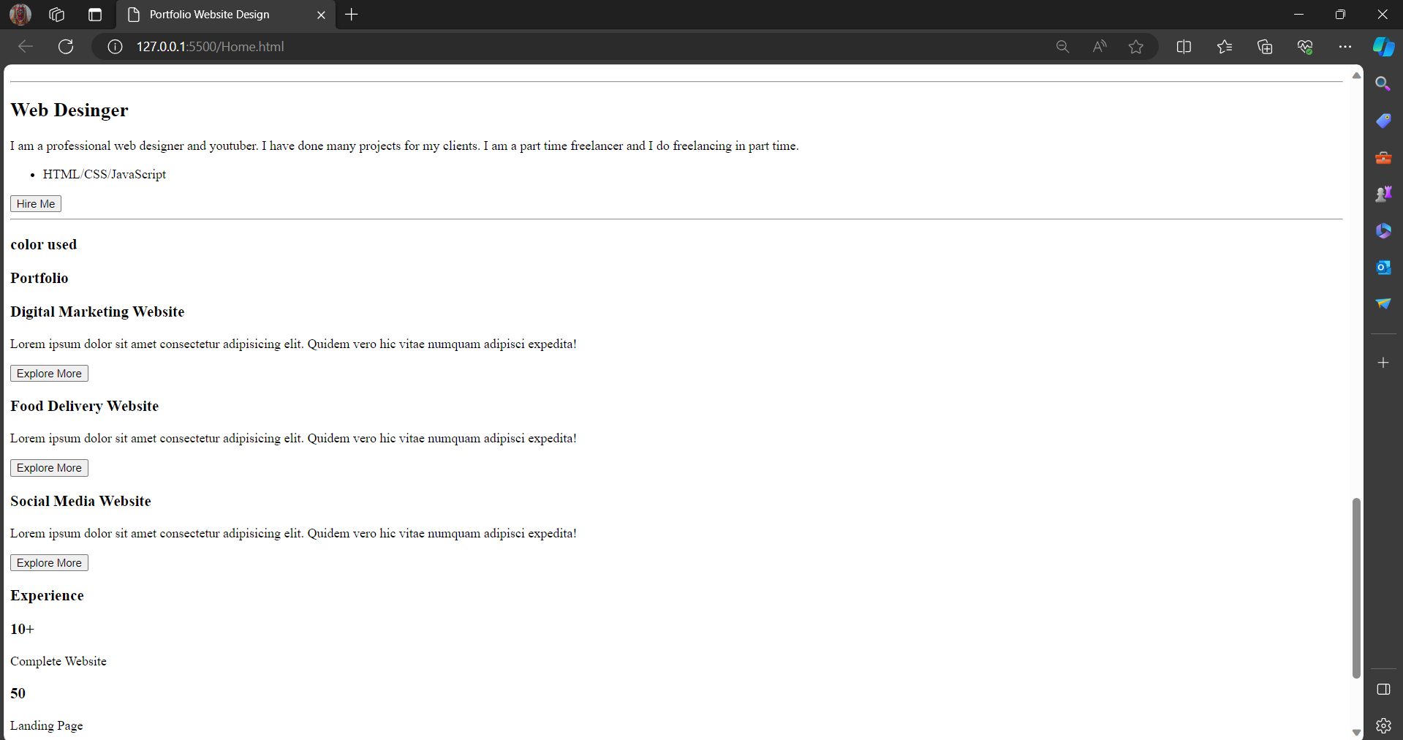

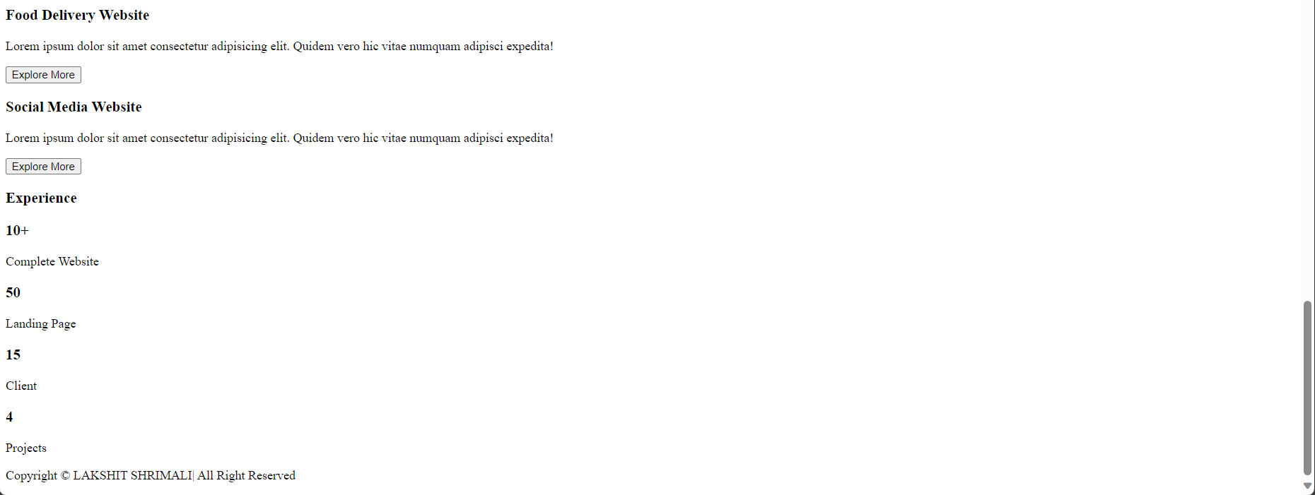

**Hom.css**

**Description**

margin

padding

background

font family

align

justify

width

background

border radius

flex right

content

display

**Source code**

@import url('https://fonts.googleapis.com/css2?family=Montserrat:wght@500;600;700&family=Poppins:wght@400;500;600;700&display=swap');

*{

    margin: 0;

    padding: 0;

    box-sizing: border-box;

    font-family: 'Montserrat', sans-serif;

}

:root{

    --primary-color: #fff;

    --primary-shade: #f7f5f2;

    --seconday-color: #000;

    --secondary-shade: #4b4c4c;

    --red-color: #d40700;

    --red-shade: #b20600;

    --accent-color: #ffee63;

}

ul li{

    list-style: none;

}

a{

    text-decoration: none;

}

/* header section  */

header{

    background: rgb(2, 0, 36);

    background: linear-gradient(90deg, rgba(2, 0, 36, 1) 0%, rgba(50, 50, 51, 1) 35%, rgba(0, 212, 255, 1) 100%);

    background: linear-gradient(to right, #040404, #242424, #656565);

    color: var(--primary-color);

}

.nav-bar {

    padding: 30px 0;

}

span{

    color: var(--red-color);

}

ul li a{

    margin: 0 10px;

    padding: 0 5px;

    color: var(--accent-color);

    font-size: 18px;

    cursor: pointer;

    position: relative;

}

ul li a::before{

    content: '';

    width: 0;

    position: absolute;

    bottom: -5px;

    left: 0;

    height: 2px;

    background-color: var(--primary-color);

    transition: 0.6s ease;

}

ul li a:hover::before{

    width: 100%;

}

/* button  */

.btn{

    width: 100px;

    height: 40px;

    border-radius: 8px;

    background-color: var(--red-color);

    color: var(--primary-color);

    outline: none;

    border: none;

    cursor: pointer;

    font-size: 16px;

    padding: 0 5px;

    font-weight: 500;

}

.btn:hover{

    background-color: var(--red-shade);

    color: var(--primary-shade);

    border: 2px solid var(--red-color);

}

/* header content  */

.content{

    height: 90vh;

    position: relative;

}

.content .right img{

    width: 120%;

    position: relative;

    z-index: 999;

    cursor: pointer;

    transition: 0.3s ease;

}

.content .right img:hover{

    filter: drop-shadow(16px 5px 20px burlywood);

}

h4, p{

    font-family: 'Poppins', sans-serif;

}

.color-box{

    width: 560px;

    height: 480px;

    border: 5px solid red;

    transform: rotate(48deg);

    position: absolute;

    top: 120px;

    right: 10px;

}

/* about sec  */

.about-me-sec{

    min-height: 40vh;

    background-color: var(--secondary-shade);

    color: var(--primary-color);

}

.about-me-sec hr{

    border: 2px solid red;

    margin-bottom: 2rem;

}

.about-content img{

    width: 100%;

    transform: scaleX(-1);

}

.about-content ul{

    margin-top: 25px;

    margin-bottom: 10px;

}

.about-content span{

    color: #C6DCE4;

}

.dot{

    width: 22px;

    height: 22px;

    border-radius: 50%;

    display: inline-block;

    margin: 10px 5px;

    cursor: pointer;

}

.dot-w{

    background-color: var(--primary-color);

}

.dot-b{

    background-color: var(--seconday-color);

}

.dot-ws{

    background-color: var(--primary-shade);

}

.dot-bs{

    background-color: #C6DCE4;

}

.dot-a{

    background-color: var(--accent-color);

}

.portfolio-sec{

    height: 50vh;

    background-color: burlywood;

}

.portfolio > h3{

    color: var(--primary-color);

    margin-bottom: 50px;

}

.portfolio-child img{

    width: 100%;

}

.portolio-parent{

    gap: 30px;

}

.portfolio-child{

    border: 1px solid var(--red-color);

    border-radius: 8px;

    transition: 0.3s ease;

    cursor: pointer;

}

.portfolio-child:hover{

    transform: scale(1.1);

    background-color: lavender;

}

.portfolio-child h3{

    margin-top: 10px;

}

.portfolio-child p{

    margin-top: 5px;

    line-height: 1.4;

    text-align: left;

    padding-left: 10px;

    padding-bottom: 10px;

}

.portfolio-child button{

    margin: 15px;

}

/* experience sec  */

.experience-sec{

    height: 35vh;

    background-color: var(--secondary-shade);

    color: var(--primary-color);

}

.experience{

    padding: 0 30px 0 30px;

}

.experience-details{

    border-bottom: 2px solid var(--red-color);

    padding-bottom: 30px;

    margin-top: 40px;

}

.col p{

    padding-top: 14px;

    text-transform: uppercase;

}

.right-sec input{

    margin-left: 10px;

}

.right-sec button{

    margin-left: 35px;

    margin-top: 15px;

}

footer{

    background-color: var(--secondary-shade);

    padding: 10px 0;

    color: burlywood;

}

#click, .menu-btn i{

    display: none;

}

**Output**

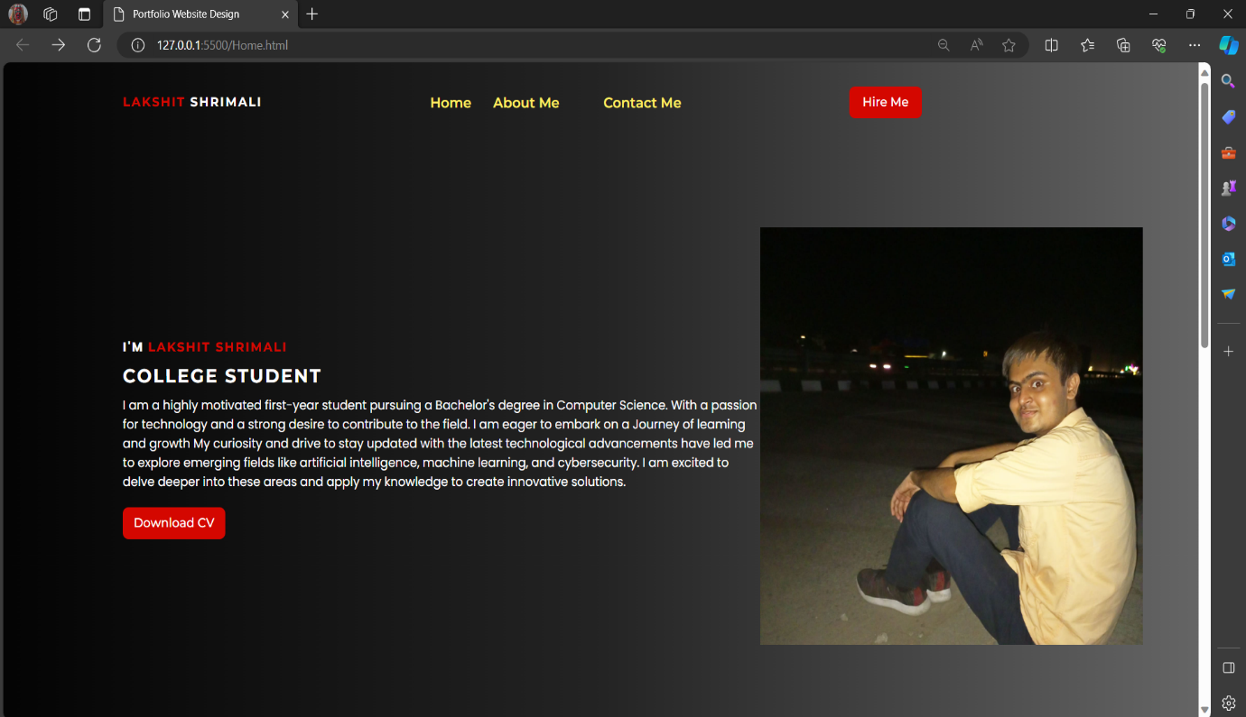

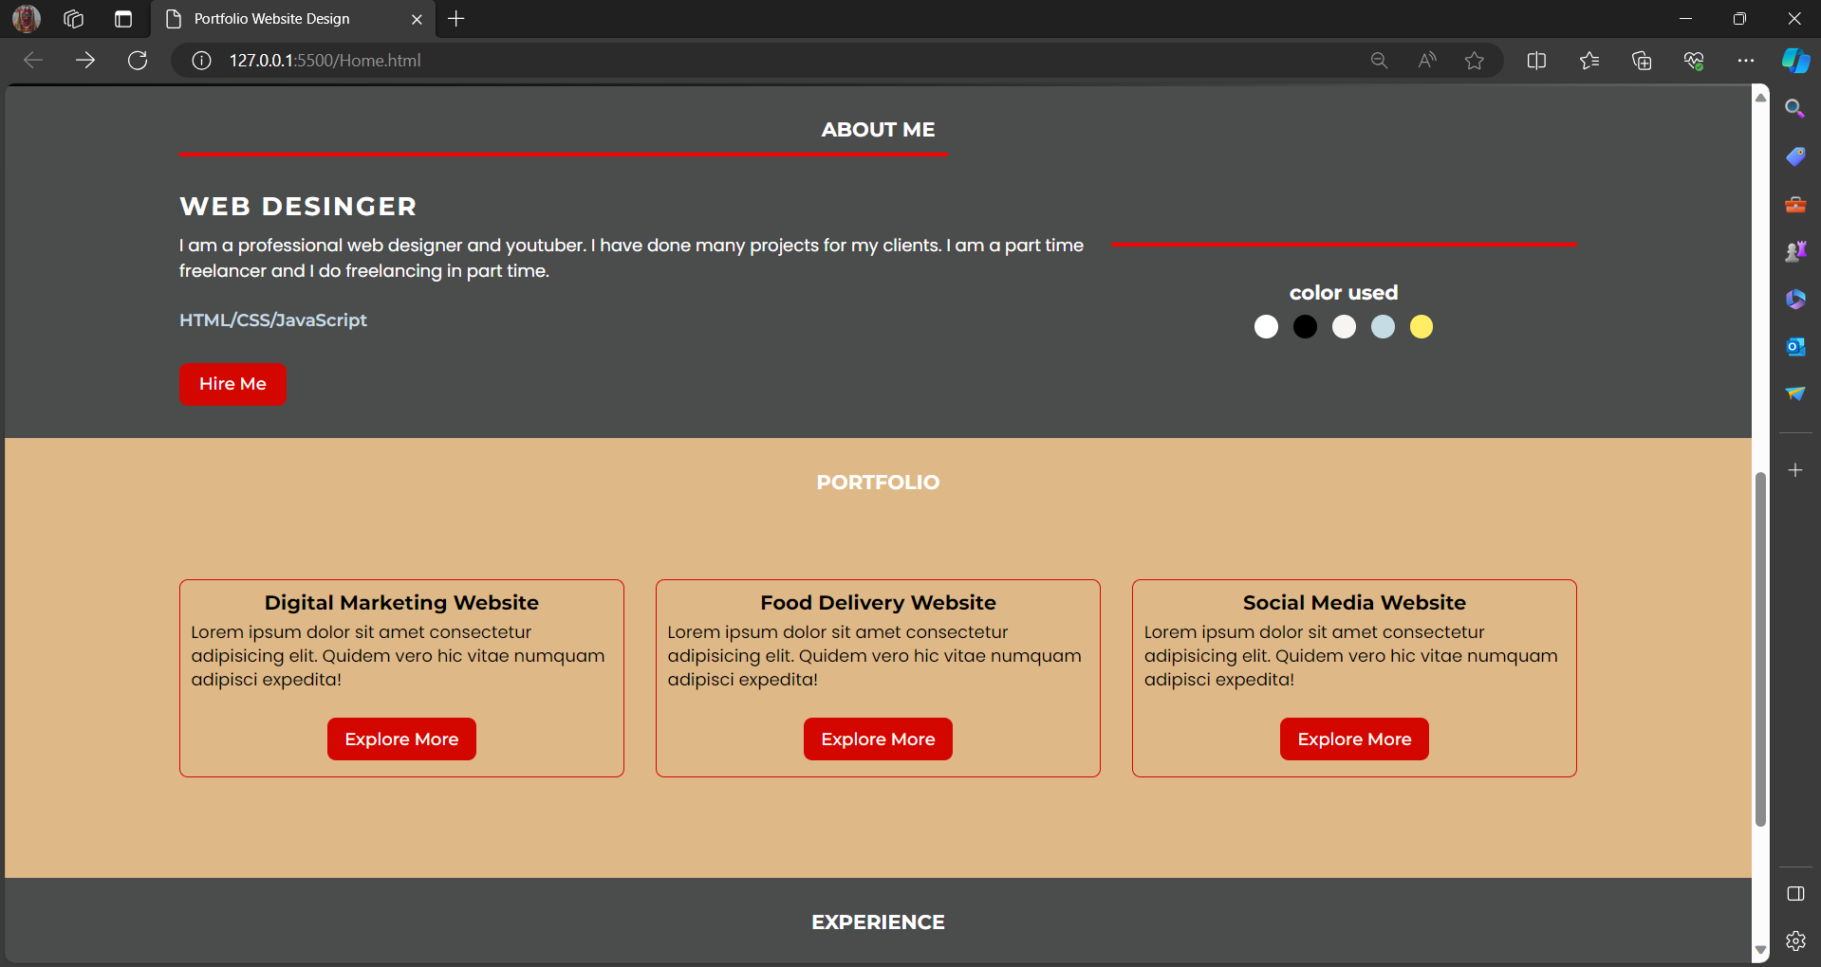

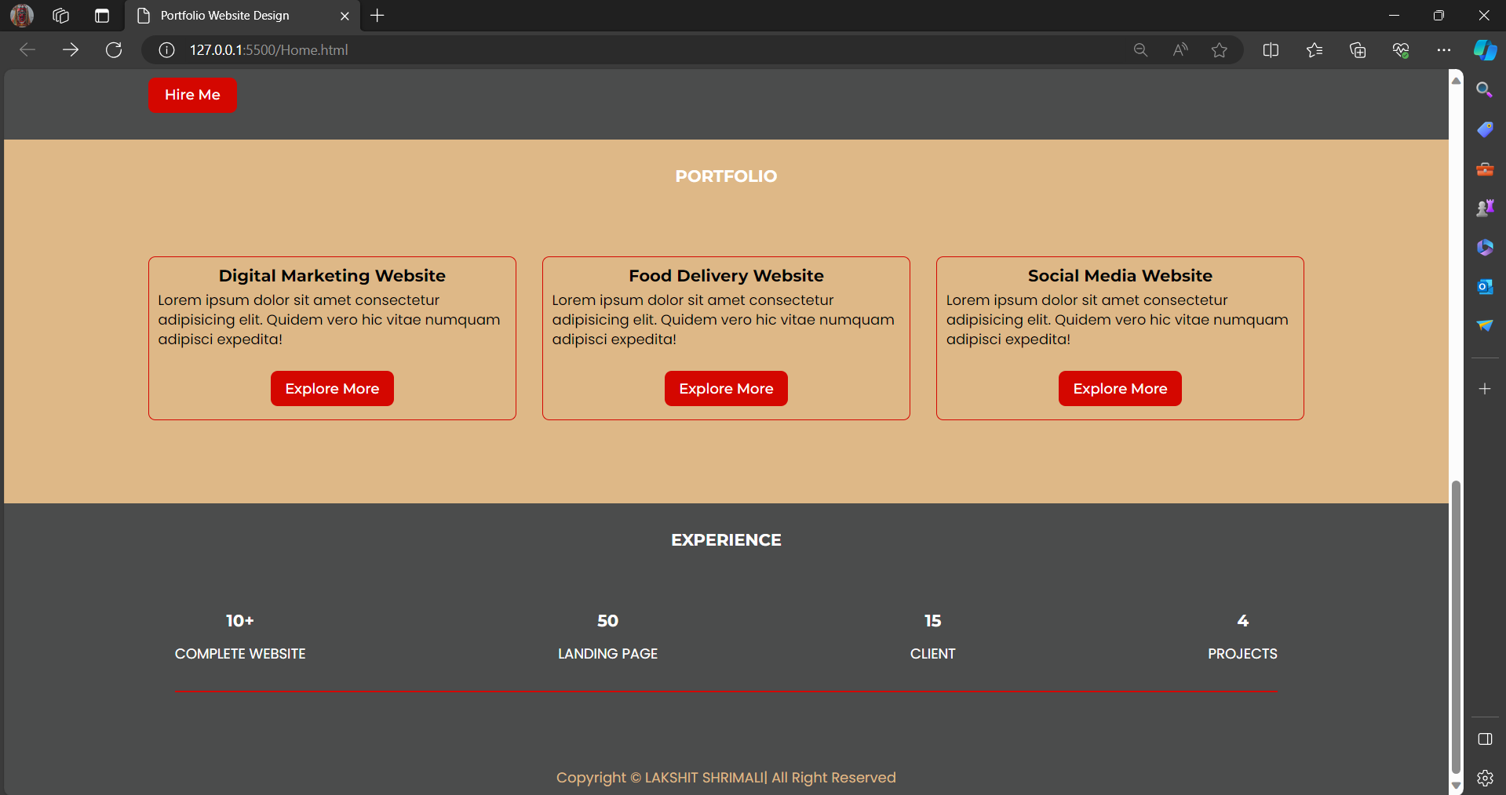

**Home.css**

**Description**

margin

padding

background

font family

align

justify

width

background

border radius

flex right

content

display

**Source Code**

**.layout**

**{**

**width:80%;**

**margin:0 auto;**

**}**

**.flex**

**{**

**display:flex;**

**}**

**.space-between**

**{**

**justify-content:space-between;**

**}**

**.align-center{**

**align-items:center;**

**}**

**.justify-center**

**{**

**justify-content: center;**

**}**

**.uppercase**

**{**

**text-transform:uppercase;**

**}**

**.f-w-500**

**{**

**font-weight:500;**

**}**

**.f-w-600**

**{**

**font-weight:600;**

**}**

**.f-w-700**

**{**

**font-weight:700;**

**}**

**.letter-spacing2**

**{**

**letter-spacing:2px;**

**}**

**.btn2**

**{**

**width:140px;**

**}**

**.flex2**

**{**

**flex:2;**

}

.flex3

{

    flex:1

}

.my-t-10

{

    margin-top:10px;

}

.my-t-20

{

    margin-top:20px;

}

.pd-t-30

{

    padding-top:30px;

}

.w55

{

    width:55%;

}

.text-center

{

    text-align:center;

}

.pd-30

{

    padding:30px;

}

**Output**

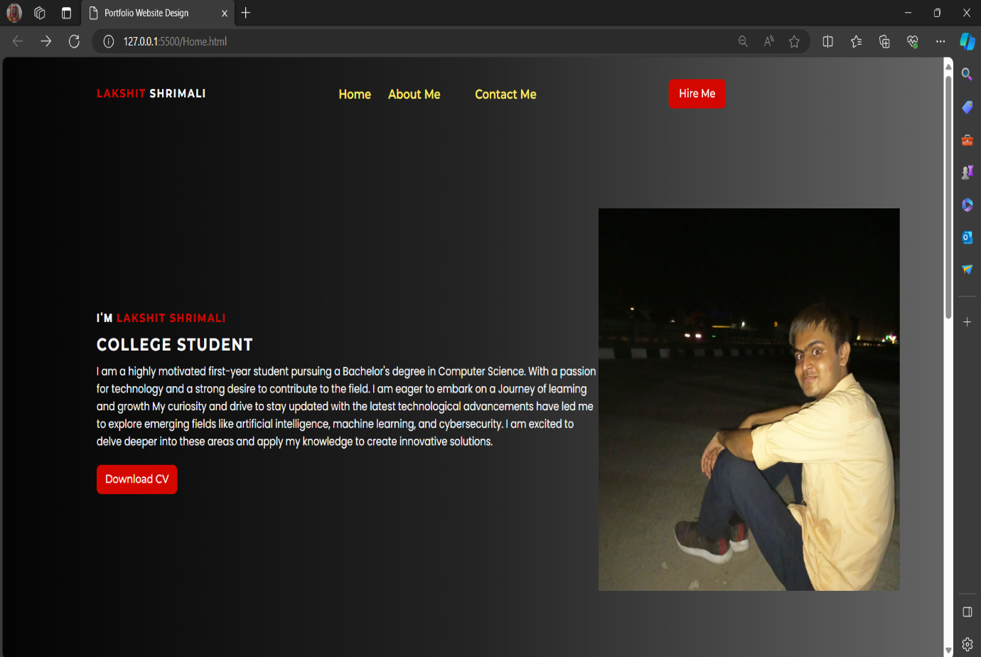



**Aboutme.html**

**Description**

Html tag

Head tag

Body tag

Header tag

Footer tag

Section tag

Heading tags

Style tag

Body tag

Span tag

Division tag

Paragraph tag

Table tag

List tag

Unordered tag

Definition list

Table row tag

Table definition tag

Image tag

**Source Code**

<html>

  <head>

    <title>Portfolio - LAKSHIT SHRIMALI</title>

    <link rel="stylesheet" href="About me.css">

  </head>

  <body style="background-color: #0fb869cb">

    <header class="header">

    <section>

      <h2 style="color: rgb(220, 20, 213)">About me:-</h2>

      <div style="font-size: larger">Date of Birth: 22 December 2004</div>

      <p class="p"; style="font-size: larger">

        I am a highly motivated first-year student pursuing a Bachelor's degree in Computer Science. With a passion for technology and a strong desire to contribute to the field. I am eager to embark on a Journey of leaming and growth

            My curiosity and drive to stay updated with the latest technological advancements have led me  to explore emerging fields like artificial intelligence, machine learning, and cybersecurity. I am excited to delve deeper into these areas and apply my knowledge to create innovative solutions.

       </p>

      <h2 style="color: rgb(77, 20, 220)">Skills:-</h2>

      <table

        border="2"

        cellspacing="4"

        cellpadding="15"

        style="font-size: larger"

        <tr>

          <th>Skills</th>

          <th>Level</th>

        </tr>

        <tr>

          <td>Object-Oriented Programming (OOP) [C,C++]</td>

          <td>Advanced</td>

        </tr>

        <tr>

          <td>Java Programming</td>

          <td>Advanced</td>

        </tr>

        <tr>

          <td>Problem Solving</td>

          <td>Intermediate</td>

        </tr>

        <tr>

          <td>Data structure and Algorithms</td>

          <td>Intermediate</td>

        </tr>

        <tr>

          <td>Writtten and verbal Communication</td>

          <td>Advanced</td>

        </tr>

    </table>

      <h2 style="color: rgb(20, 133, 220)">Languages:-</h2>

      <ul type="square" style="font-size: larger">

        <li>English</li>

        <li>Hindi</li>

        <li>Spanish</li>

        <li>Sanskrit</li>

      </ul>

      <h2 style="color: rgb(187, 20, 220)">Hobbies:-</h2>

      <ul style="font-size: larger">

        <li>Coding</li>

        <li>Listening Music</li>

        <li>Sports(Cricket)</li>

        <li>Running</li>

        <li>Yoga</li>

      </ul>

      <h2 style="color: rgb(20, 30, 220)">Education:-</h2>

      <table

        style="font-size: larger"

        border="2"

        cellspacing="4"

        cellpadding="15"

        <tr>

          <th>Year</th>

          <th>Education</th>

          <th>Scores</th>

        </tr>

        <tr>

          <td>20</td>

          <td>

            10<sup>th</sup> from C.B.S.E. Board <br />

            (from St. Gregorios Sr. Sec. School,Udaipur)

          </td>

          <td>94%</td>

        </tr>

        <tr>

          <td>2022</td>

          <td>

            12<sup>th</sup> from C.B.S.E. Board <br />

            (from Mds Public School,Udaipur)

          </td>

          <td>73%</td>

        </tr>

        <tr>

          <td>2022-2026 [Pursuing](September)</td>

          <td>

            Bachelor of Technology : Computer Science & Enginneering <br />

            (from Vellore Institute of Technology, Vellore, India)

          </td>

          <td>8.4 CGPA [Current]</td>

        </tr>

      </table>

      <h2 style="color: rgb(20, 77, 220)">Learning Interest:-</h2>

      <ol style="font-size: larger">

        <li>Artificial Intelligence & Machine Learning</li>

        <li>Cybersecurity</li>

        <li>Web Development</li>

        <li>Software Enginneering</li>

    </ol>

    <img src="WhatsApp Image 2024-01-28 at 22.54.43_cff05aa9.jpg" alt="Lakshit Shrimali" class="float-left" width="200">

    <img src="coding.jpg" alt="Coding" class="float-right" width="200">

    <img src="Music.jpg" alt="Listening to Music" class="float-left" width="200">

    <img src="Cricket.jpg" alt="Playing Cricket" class="float-right" width="200">

    <div class="clear"></div>

    </div>

      <footer>

        <p style="text-align: center">&copy;Lakshit Shrimali</p>

      </footer>

    </section>

  </body>

</html>

**OUTPUT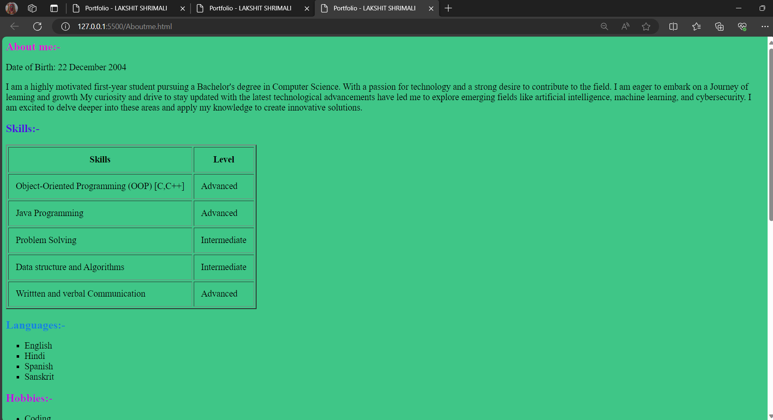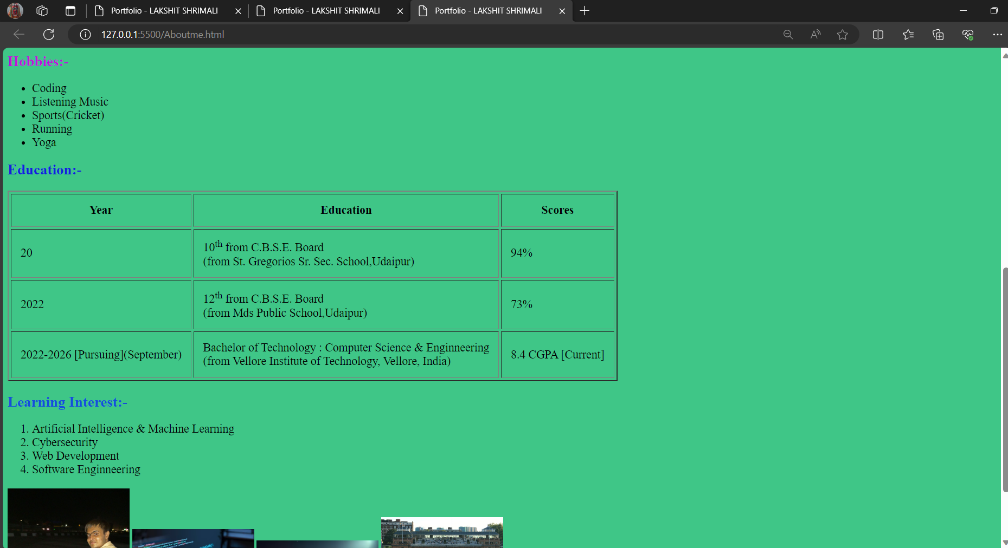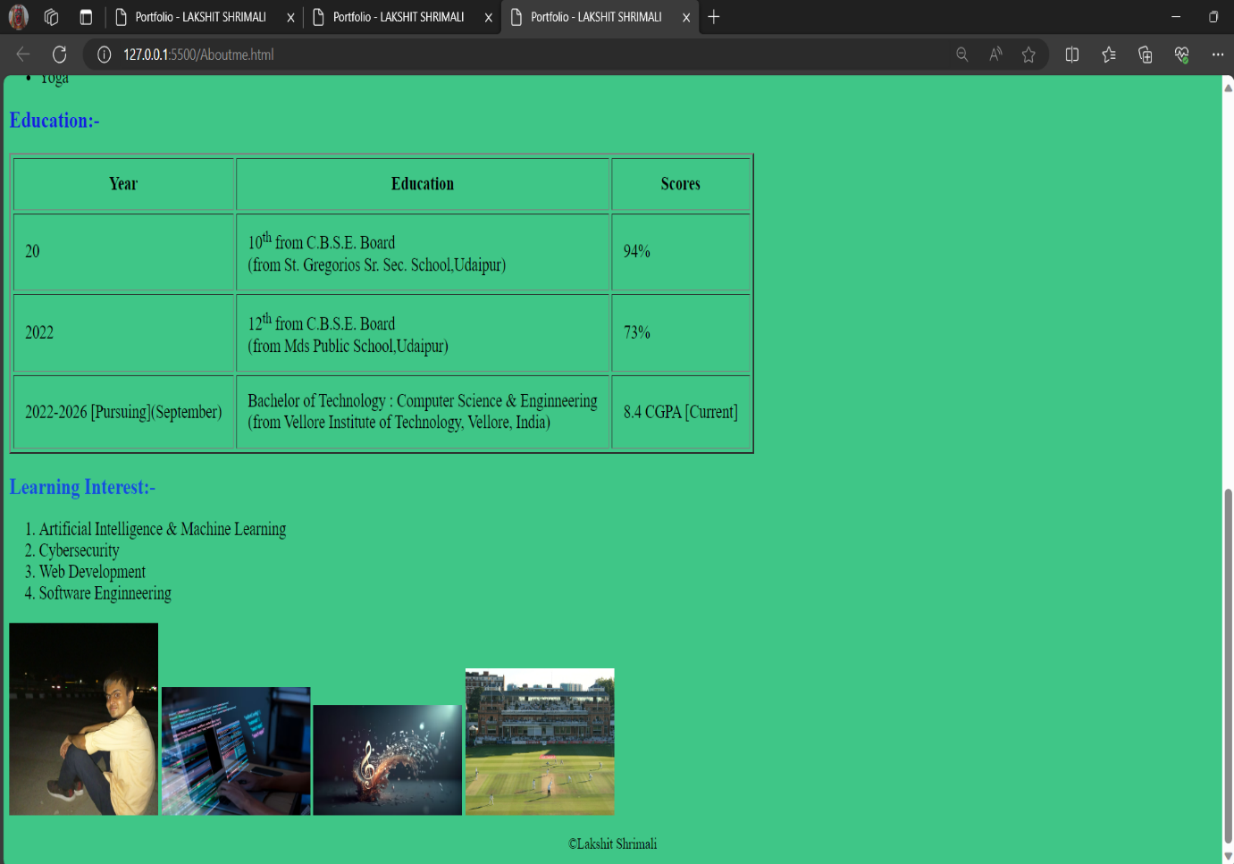About me.css**

**Description**

margin

padding

background

font family

align

justify

width

background

border radius

flex right

content

display

**Source Code**

body

{

    font-family: Arial, sans-serif;

    margin: 0;

    padding: 0;

    background-image: url('background.jpg'); /* Change to your background image */

    background-size: cover;

  }

.header

{

    background-color: rgba(255, 255, 255, 0.8);

    padding: 20px;

    text-align: center;

  }

.header h1

{

    margin-top: 0;

}

.container

{

    max-width: 800px;

    margin: 0 auto;

    padding: 20px;

    background-color: rgba(255, 255, 255, 0.8);

}

.skills-table

{

    width: 100%;

    border-collapse: collapse;

    margin-bottom: 20px;

}

.skills-table th,

.skills-table td

{

    border: 1px solid #ddd;

    padding: 8px;

    text-align: left;

}

.skills-table th

{

    background-color: #f2f2f2;

}

footer

{

    background-color: #333;

    color: #fff;

    padding: 10px 0;

    text-align: center;

    margin-top: 20px;

}

footer p

{

    margin: 0;

}

.float-left

{

    float: left;

    margin-right: 20px;

    margin-bottom: 20px;

}

.float-right

{

    float: right;

    margin-left: 20px;

    margin-bottom: 20px;

}

.clear

{

    clear: both;

}

**Output**

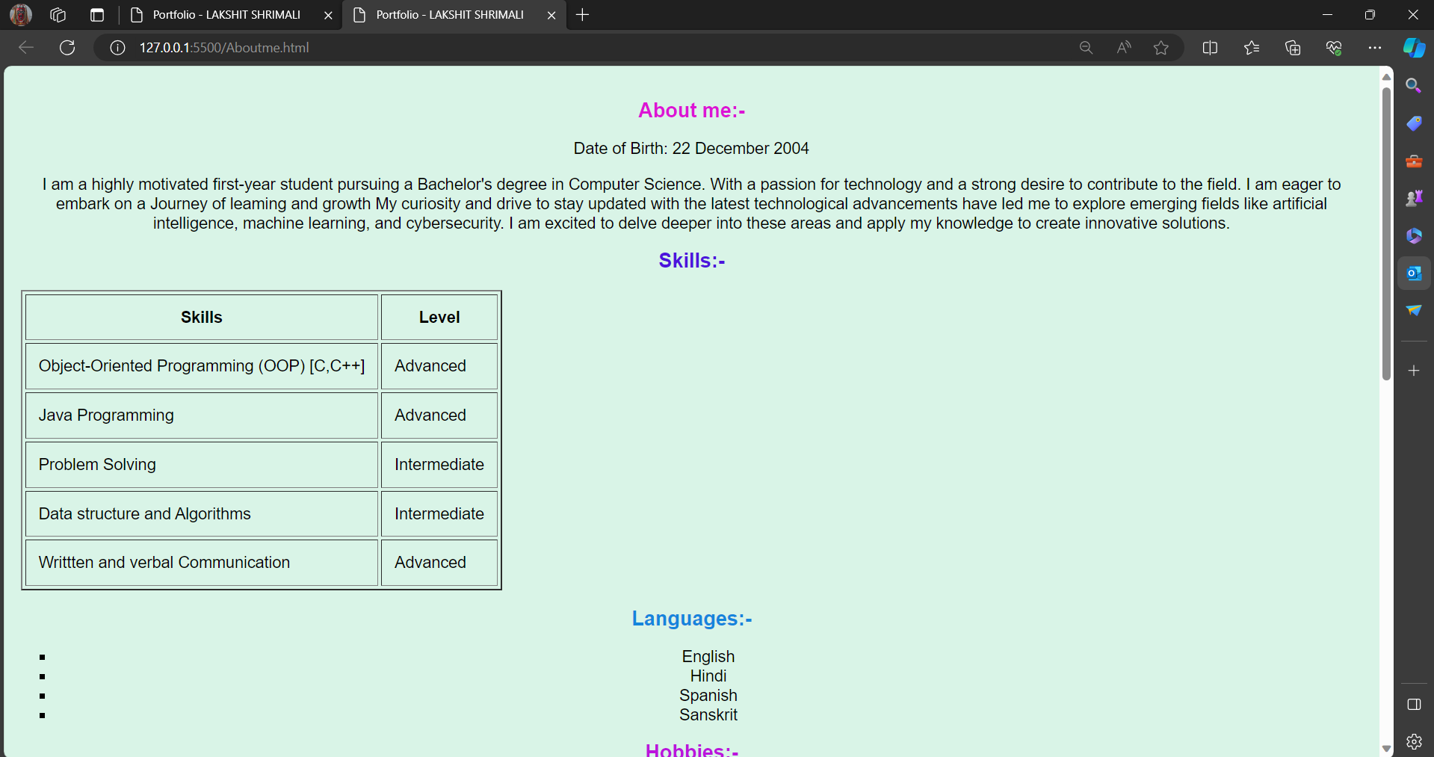

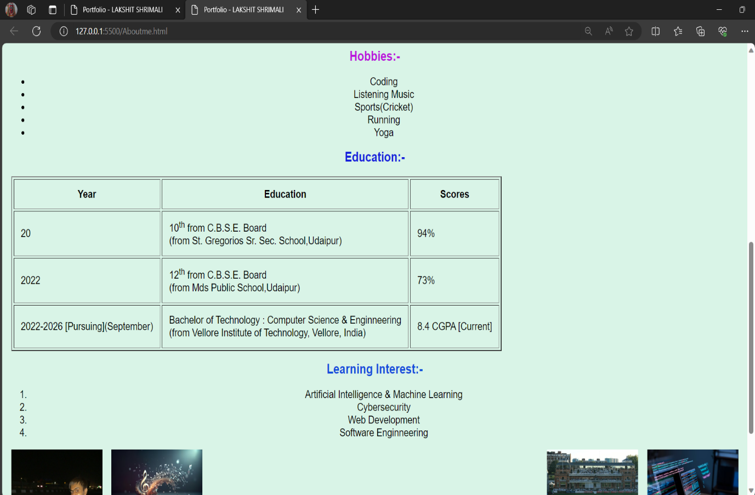

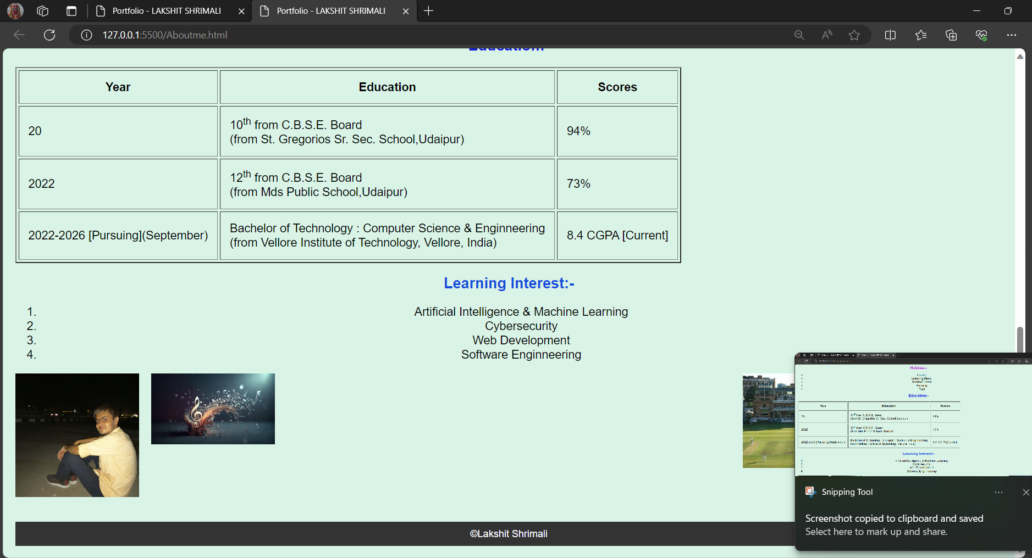

**Contact.html**

**Description**

Html tag

Head tag

Body tag

Header tag

Footer tag

Section tag

Heading tags

Style tag

Body tag

Span tag

Division tag

Paragraph tag

Button

Image tag

**Source Code**

<!DOCTYPE html>

<html lang="en" dir="ltr">

  <head>

    <meta charset="UTF-8">

    <title> Responsive Contact Us Form  | CodingLab </title>

    <link rel="stylesheet" href="Contact.css">

    <link rel="stylesheet" href="https://cdnjs.cloudflare.com/ajax/libs/font-awesome/5.15.2/css/all.min.css"/>

     <meta name="viewport" content="width=device-width, initial-scale=1.0">

   </head>

<body>

  <div class="container">

    <div class="content">

      <div class="left-side">

        <div class="address details">

          <i class="fas fa-map-marker-alt"></i>

          <div class="topic">Address</div>

          <div class="text-one">36,Tulsi Nagar,Manoharpura,Badgaon</div>

          <div class="text-two">Udaipur,Rajasthan</div>

        </div>

        <div class="phone details">

          <i class="fas fa-phone-alt"></i>

          <div class="topic">Phone</div>

          <div class="text-one">+91 82099 34134</div>

          <div class="text-two">+91 8955024501</div>

        </div>

        <div class="email details">

          <i class="fas fa-envelope"></i>

          <div class="topic">Email</div>

          <div class="text-one">lakshitshrimali2004@gmail.com</div>

          <div class="text-two">lakshit.shrimali2022@vitstudent.ac.in</div>

        </div>

      </div>

      <div class="right-side">

        <div class="topic-text">Send me a message</div>

        <p>If you have any job for me or any types of internship opportunity related to my , you can send me message from here. It's my pleasure to help you.</p>

      <form action="#">

        <div class="input-box">

          <input type="text" placeholder="Enter your name">

        </div>

        <div class="input-box">

          <input type="text" placeholder="Enter your email">

        </div>

        <div class="input-box message-box">

        </div>

        <div class="button">

          <input type="button" value="Send Now" >

        </div>

      </form>

    </div>

    </div>

  </div>

</body>

</html>

**Output**

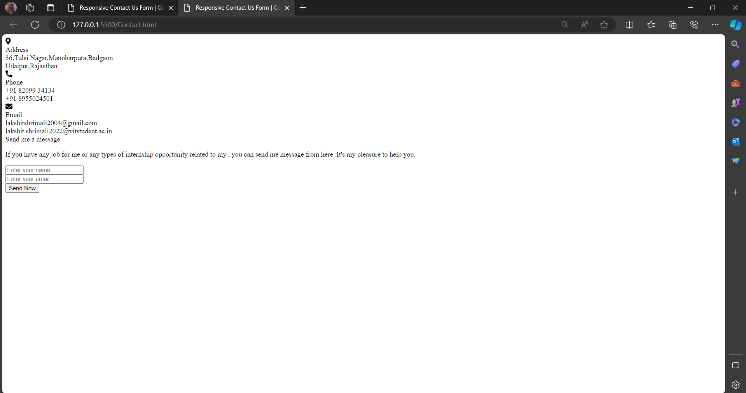

**Contact.css**

**Description**

margin

padding

background

font family

align

justify

width

background

border radius

flex right

content

display

@import url('https://fonts.googleapis.com/css2?family=Poppins:wght@200;300;400;500;600;700&display=swap');

*{

  margin: 0;

  padding: 0;

  box-sizing: border-box;

  font-family: "Poppins" , sans-serif;

}

body{

  min-height: 100vh;

  width: 100%;

  background:rgb(2, 0, 36);;

  display: flex;

  align-items: center;

  justify-content: center;

}

.container{

  width: 85%;

  background: #fff;

  border-radius: 6px;

  padding: 20px 60px 30px 40px;

  box-shadow: 0 5px 10px rgba(0, 0, 0, 0.2);

}

.container .content{

  display: flex;

  align-items: center;

  justify-content: space-between;

}

.container .content .left-side{

    width: 25%;

    height: 100%;

    display: flex;

    flex-direction: column;

    align-items: center;

    justify-content: center;

    margin-top: 15px;

    position: relative;

  }

  .content .left-side::before{

    content: '';

    position: absolute;

    height: 70%;

    width: 2px;

    right: -15px;

    top: 50%;

    transform: translateY(-50%);

    background: #afafb6;

  }

  .content .left-side .details{

    margin: 14px;

    text-align: center;

}

.content .left-side .details i{

  font-size: 30px;

  color: #3e2093;

  margin-bottom: 10px;

}

.content .left-side .details .topic{

  font-size: 18px;

  font-weight: 500;

}

.content .left-side .details .text-one,

.content .left-side .details .text-two{

  font-size: 14px;

  color: #afafb6;

}

.container .content .right-side{

  width: 75%;

  margin-left: 75px;

}

.content .right-side .topic-text{

  font-size: 23px;

  font-weight: 600;

  color: #3e2093;

}

.right-side .input-box{

  height: 50px;

  width: 100%;

  margin: 12px 0;

}

.right-side .input-box input,

.right-side .input-box textarea{

  height: 100%;

  width: 100%;

  border: none;

  outline: none;

  font-size: 16px;

  background: #F0F1F8;

  border-radius: 6px;

  padding: 0 15px;

  resize: none;

}

.right-side .message-box{

  min-height: 110px;

}

.right-side .input-box textarea{

  padding-top: 6px;

}

.right-side .button{

  display: inline-block;

  margin-top: 12px;

}

.right-side .button input[type="button"]{

  color: #fff;

  font-size: 18px;

  outline: none;

  border: none;

  padding: 8px 16px;

  border-radius: 6px;

  background: #3e2093;

  cursor: pointer;

  transition: all 0.3s ease;

}

.button input[type="button"]:hover{

  background: #5029bc;

}

@media (max-width: 950px) {

  .container{

    width: 90%;

    padding: 30px 40px 40px 35px ;

  }

  .container .content .right-side{

   width: 75%;

   margin-left: 55px;

}

}

@media (max-width: 820px) {

  .container{

    margin: 40px 0;

    height: 100%;

  }

  .container .content{

    flex-direction: column-reverse;

  }

 .container .content .left-side{

   width: 100%;

   flex-direction: row;

   margin-top: 40px;

   justify-content: center;

   flex-wrap: wrap;

 }

 .container .content .left-side::before{

   display: none;

 }

 .container .content .right-side{

   width: 100%;

   margin-left:0;

}

}

**Output**

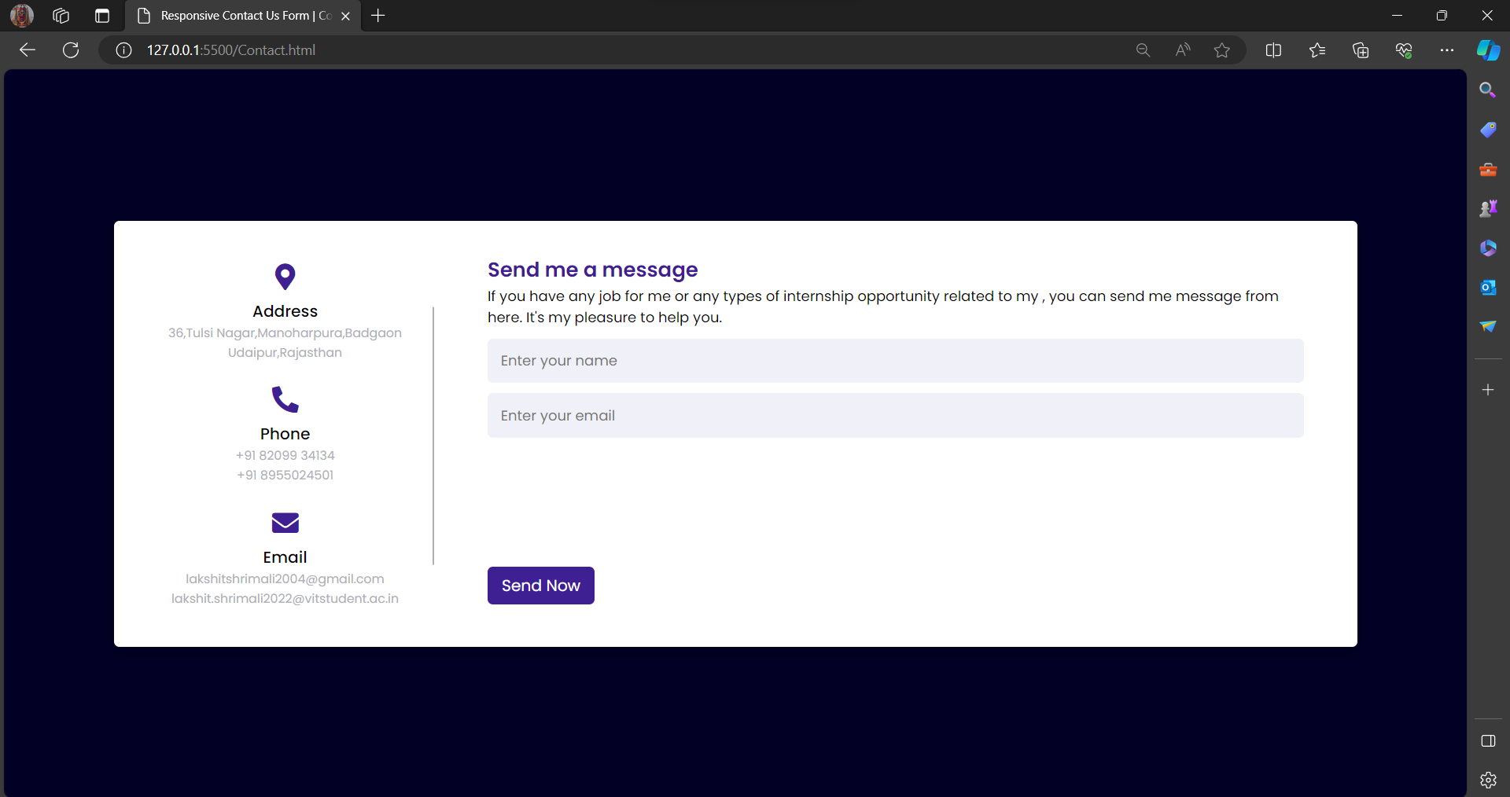

**GITHUB**

**LINK: -** https://github.com/Laxit34134/TASK-1-PORTFOLIO